**Name: Abdalrahman Omar Latif**

**Project: Data Visualization Using Excel and Tableau**

**Submission Date: 5th April, 2024**

**Password for Excel workbook: Sobatrade@2009**

**Table of Content**

|  |  |
| --- | --- |
| **Title** | **Page** |
| **First Task** |  |
| Policies and procedures when using data | 3-4 |
| **Second Task** |  |
| Excel - Screen shots illustrating work steps | 5-11 |
| **Third Task** |  |
| Tableau - Screen shots illustrating work steps | 12-15 |

**First Task**

Policies and procedures when dealing with data as a data analyst

As a data analyst, you're entrusted with handling and analyzing sensitive data. Adhering to policies and procedures ensures the integrity, security, and ethical use of data. Here are some essential policies and procedures for data analysts:

1. **Data Privacy Policy**: Understand and adhere to your organization's data privacy policy, ensuring compliance with regulations such as GDPR, CCPA, or HIPAA. Respect data subjects' rights, such as the right to access, rectify, or erase their personal data.
2. **Data Security Policy**: Follow protocols for securing data, including encryption, access controls, and secure transmission methods. Protect data from unauthorized access, breaches, and cyber threats.
3. **Confidentiality Agreement**: Sign a confidentiality agreement or non-disclosure agreement (NDA) to safeguard confidential information you have access to during your work.
4. **Data Handling Procedures**: Follow established procedures for data collection, storage, processing, and sharing. Document your data sources, methodologies, and any transformations applied to the data.
5. **Data Governance Framework**: Adhere to the organization's data governance framework, which defines roles, responsibilities, and processes for managing data assets across the organization.
6. **Quality Assurance Procedures**: Implement quality assurance procedures to ensure the accuracy, completeness, and reliability of your analyses. Validate data inputs, perform data cleaning, and conduct sanity checks on your results.
7. **Documentation Standards**: Maintain documentation for your analyses, including code, queries, assumptions, and interpretations. Document your data lineage to trace the origin and transformations of data used in your analyses.
8. **Ethical Guidelines**: Adhere to ethical guidelines for data analysis, avoiding biases, conflicts of interest, and misuse of data. Ensure transparency and fairness in your analysis methods and reporting.
9. **Compliance Training**: Stay updated on relevant laws, regulations, and industry standards through compliance training programs. Understand your legal obligations and the consequences of non-compliance.
10. **Data Retention Policy**: Abide by the organization's data retention policy, which specifies how long data should be retained before deletion or archiving. Dispose of data securely and in compliance with regulations.
11. **Data Access Controls**: Only access data that is necessary for performing your job responsibilities. Adhere to access controls and permissions defined by your organization to prevent unauthorized access to sensitive data.
12. **Reporting and Communication Protocols**: Follow protocols for reporting your findings and communicating insights to stakeholders. Present data accurately and clearly, avoiding misinterpretations or misleading visualizations.

By adhering to these policies and procedures, data analysts can ensure the responsible and ethical use of data, maintaining trust with stakeholders and mitigating risks associated with data handling and analysis.

**Second Task**

*The workbook that included below work is attached*

**Screen Shots – Excel Task**

**Setting Password for workbook**

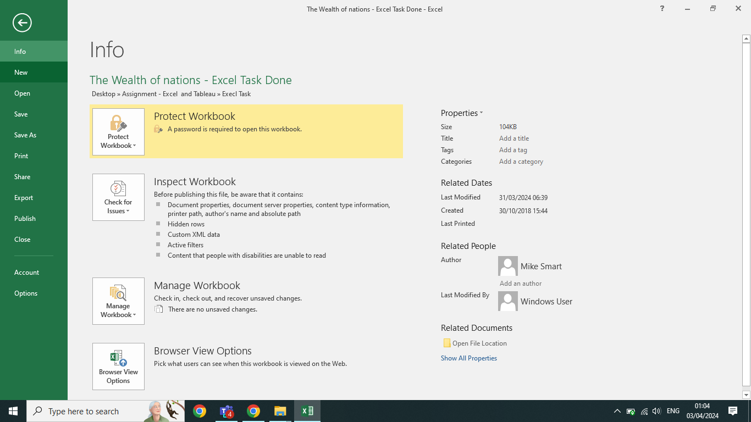

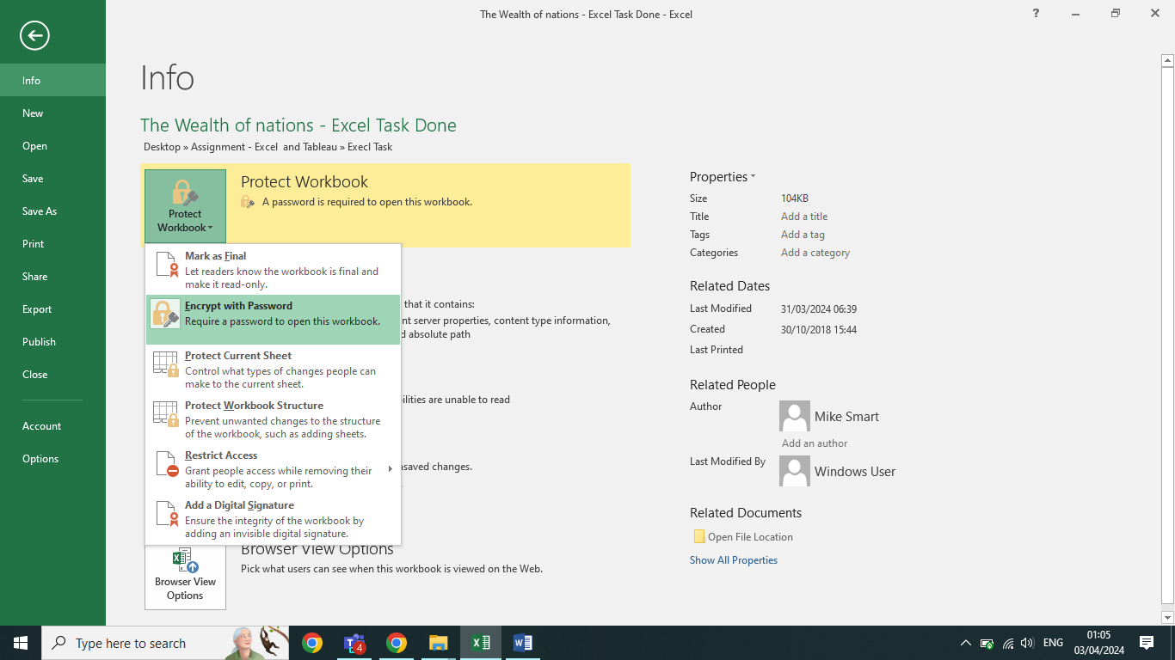

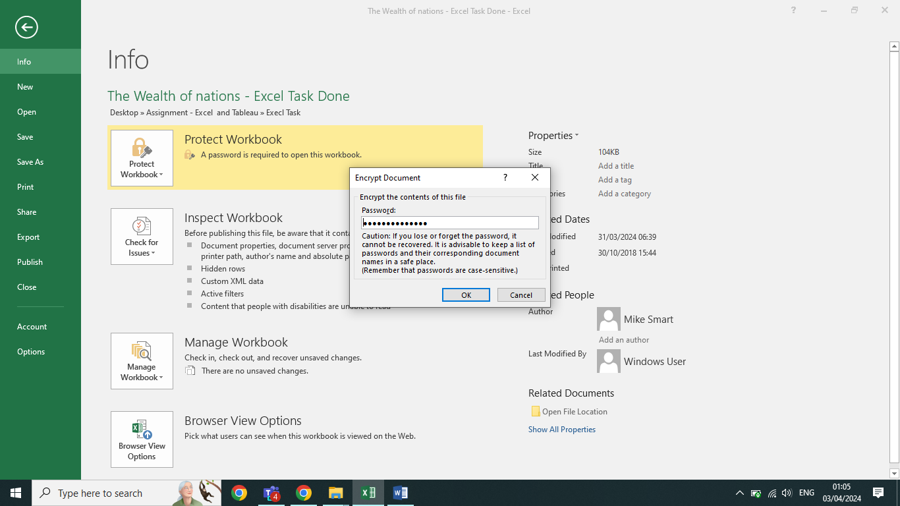

**GDP per country in 2019**

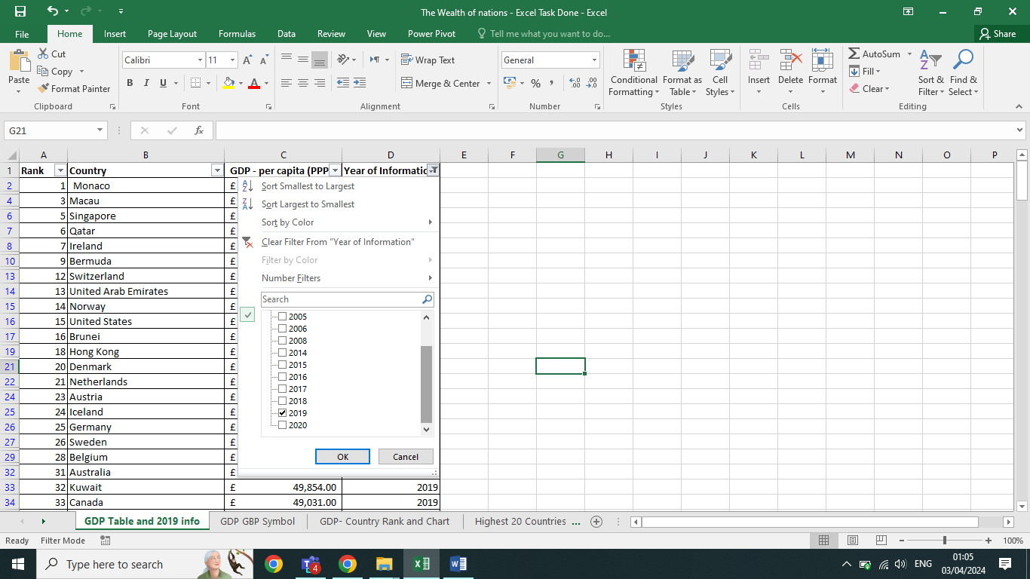

**Switch into GBP symbol**

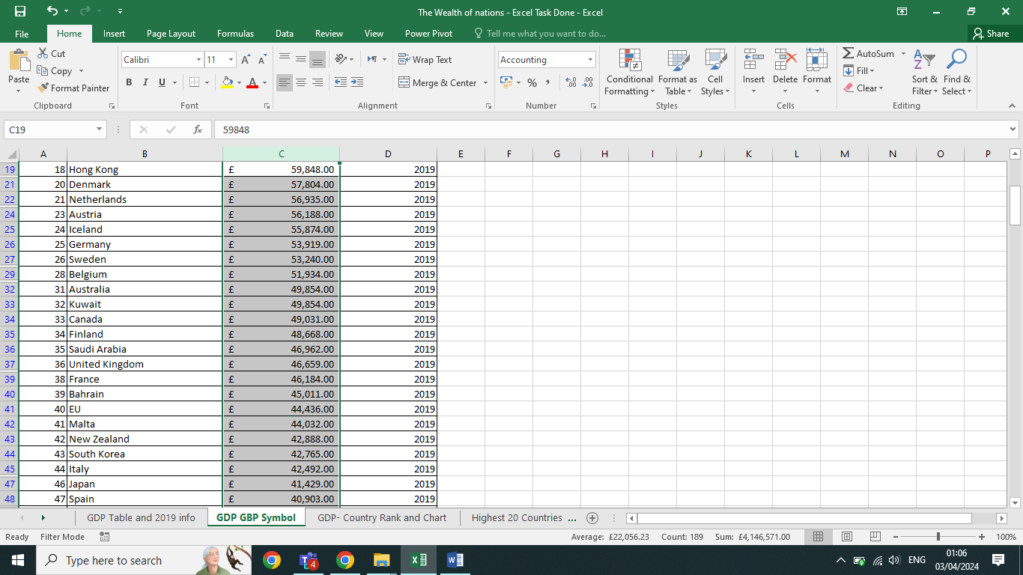

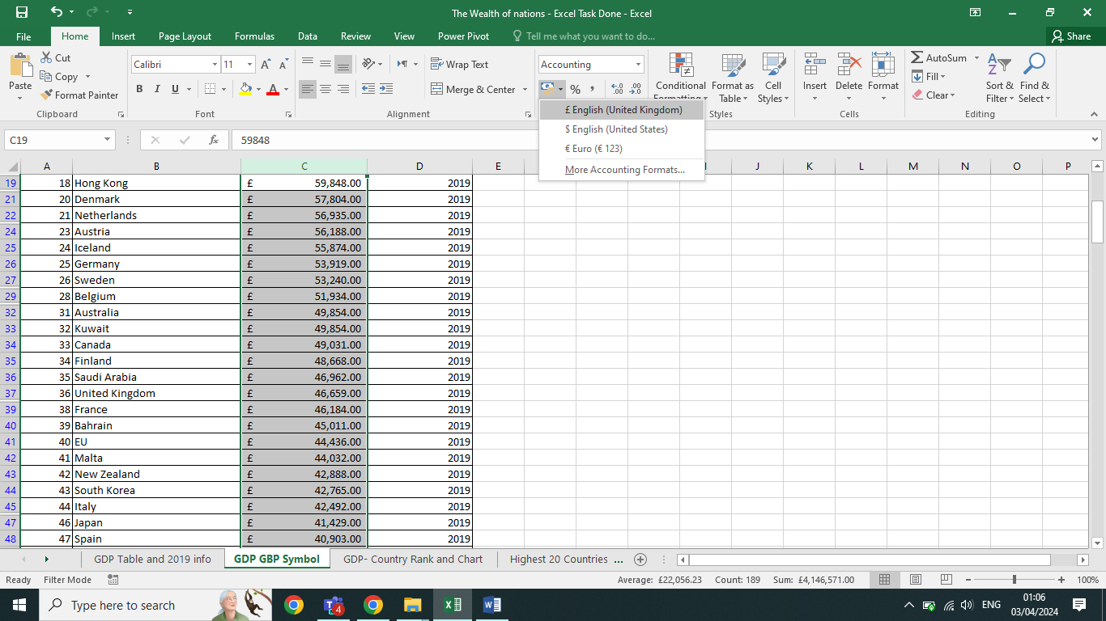

**Creating Chart for GDP, Ranking and Country**

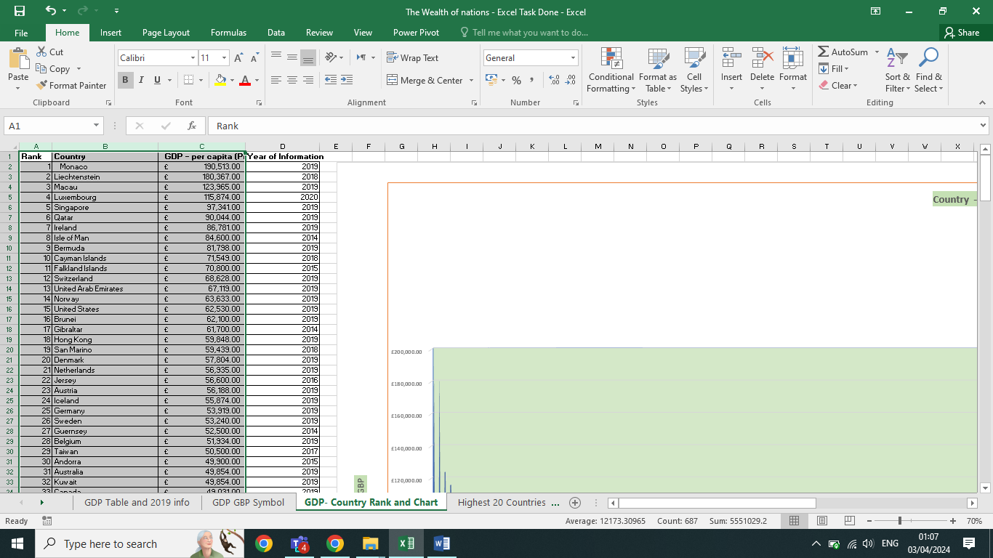

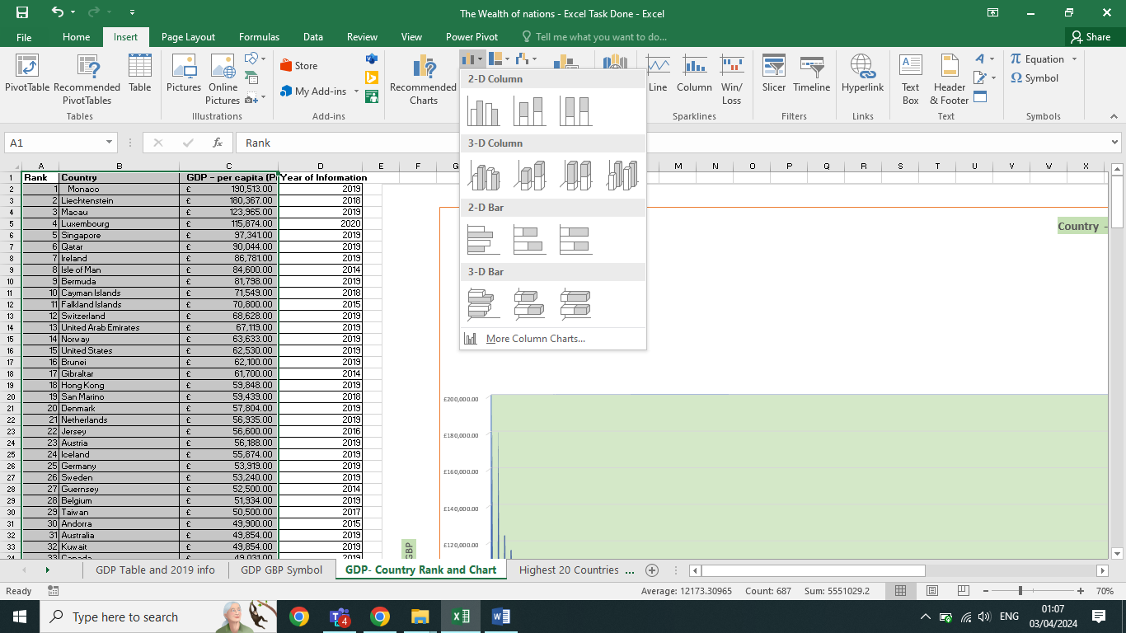

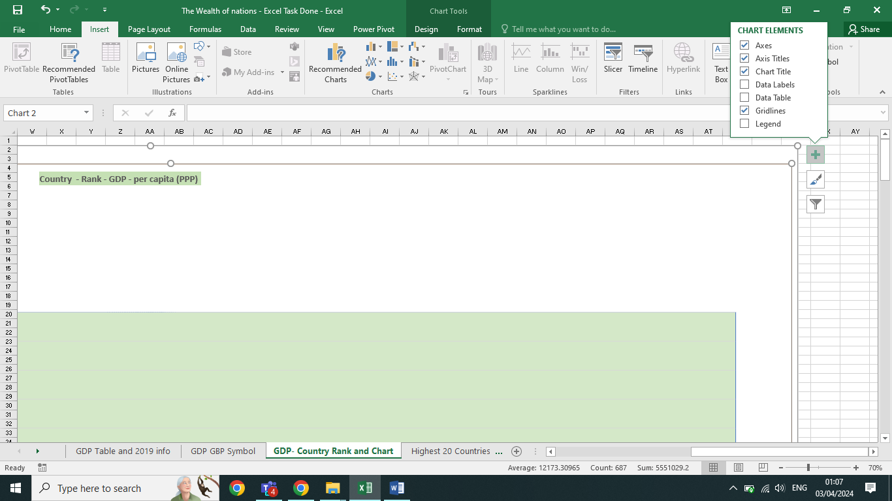

**Creating Chart for Highest 20 Countries GDP**

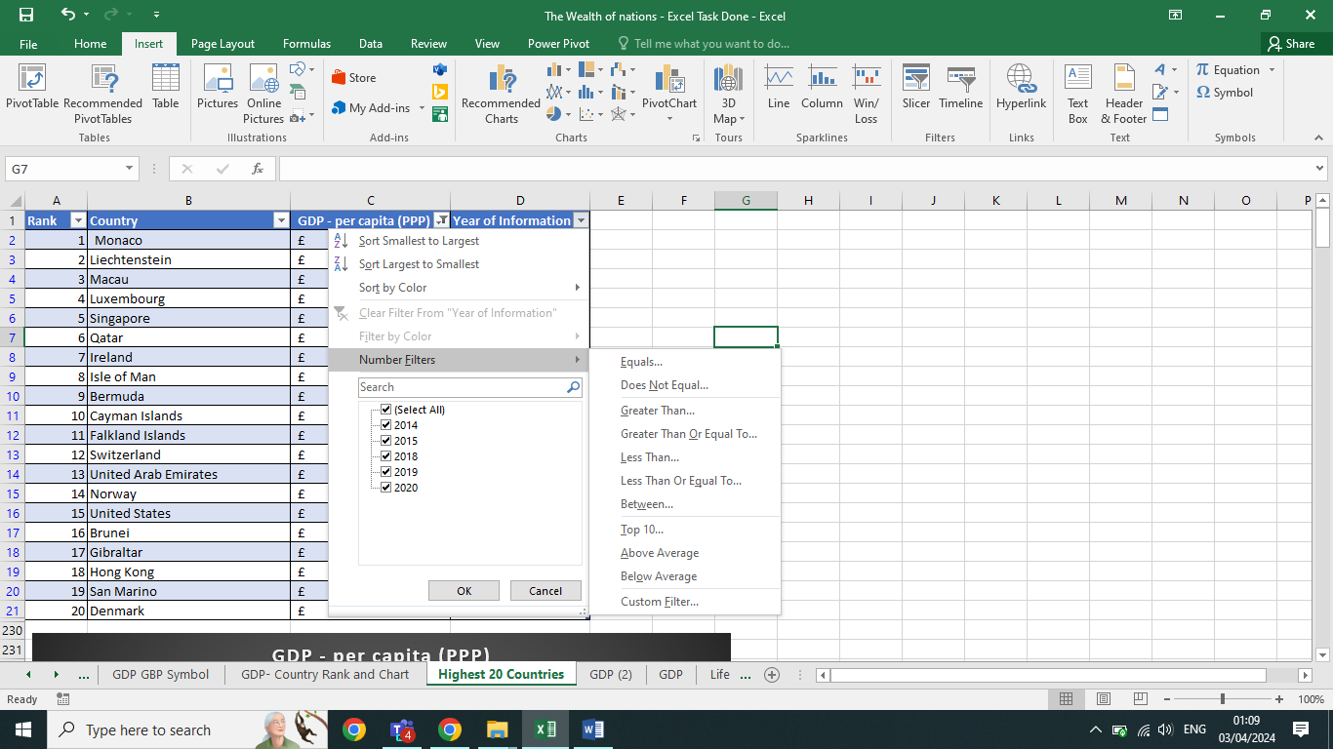

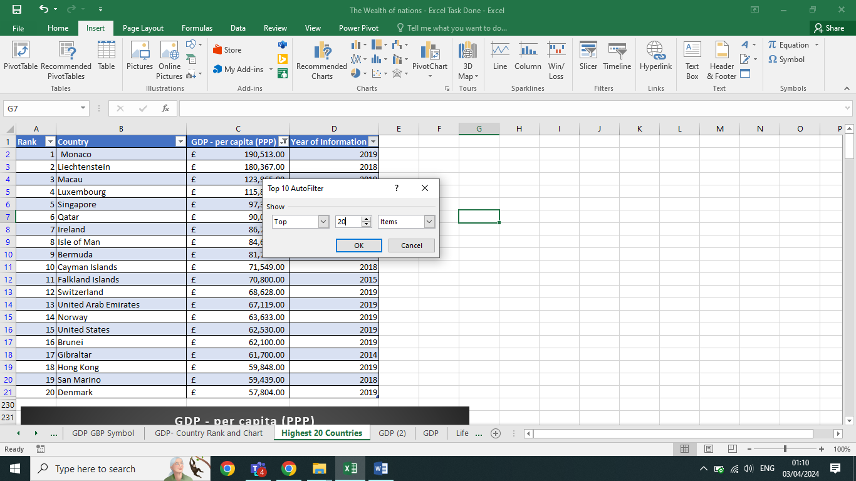

**Third Task**

**Tableau**

The following screen shot work steps

**Get data from data resource**

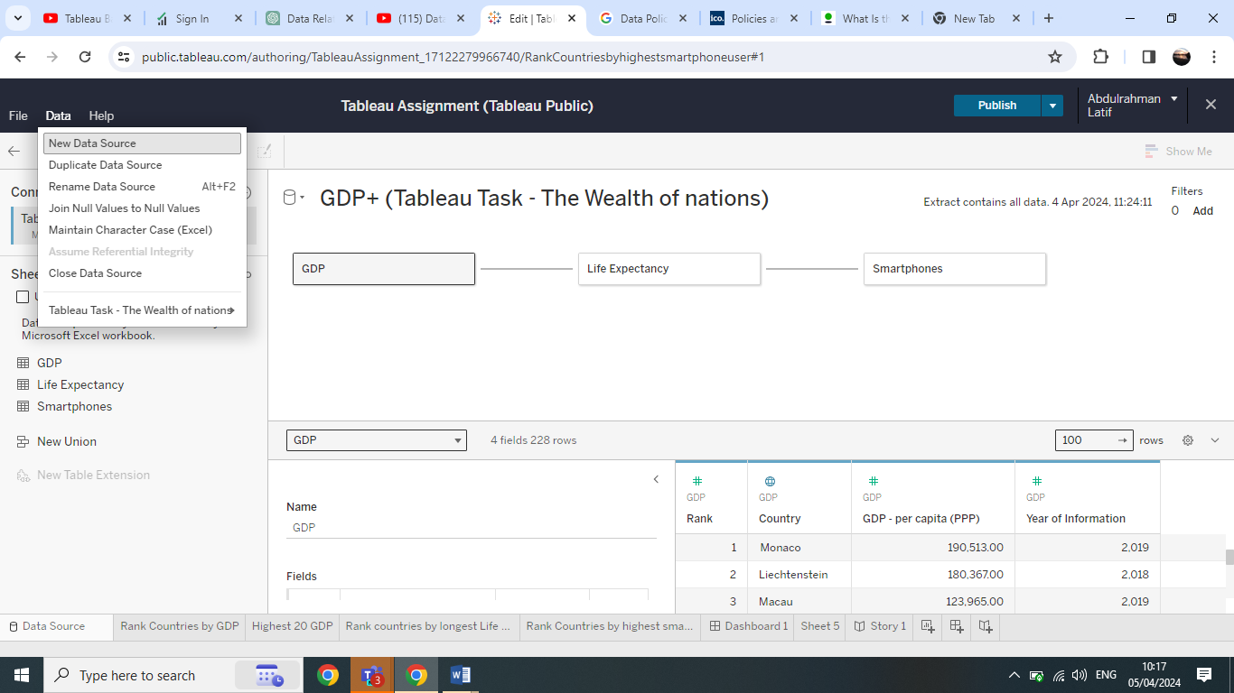

**Make data relationship between tables**

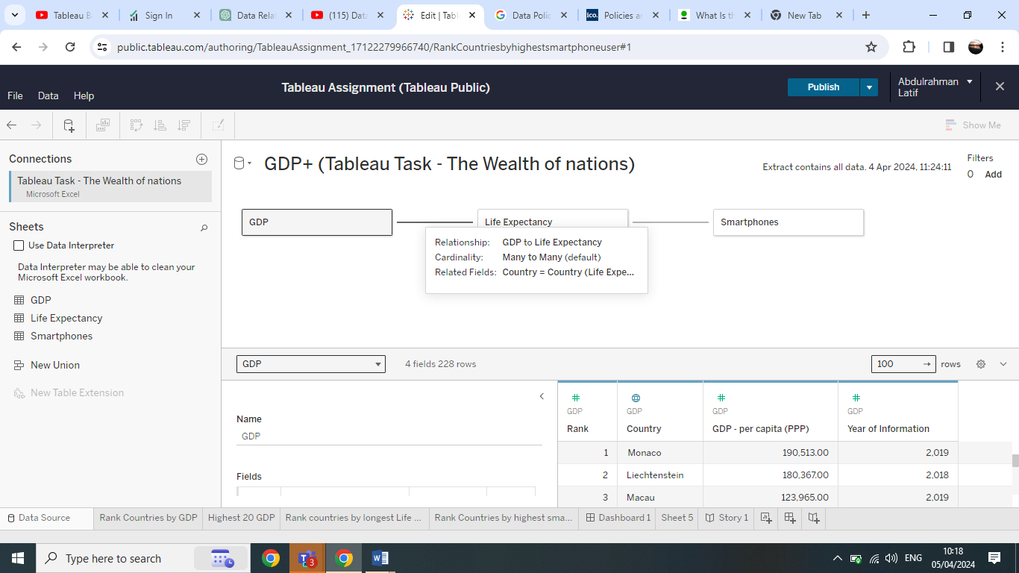

**Creating Chart illustrates GDP by countries**

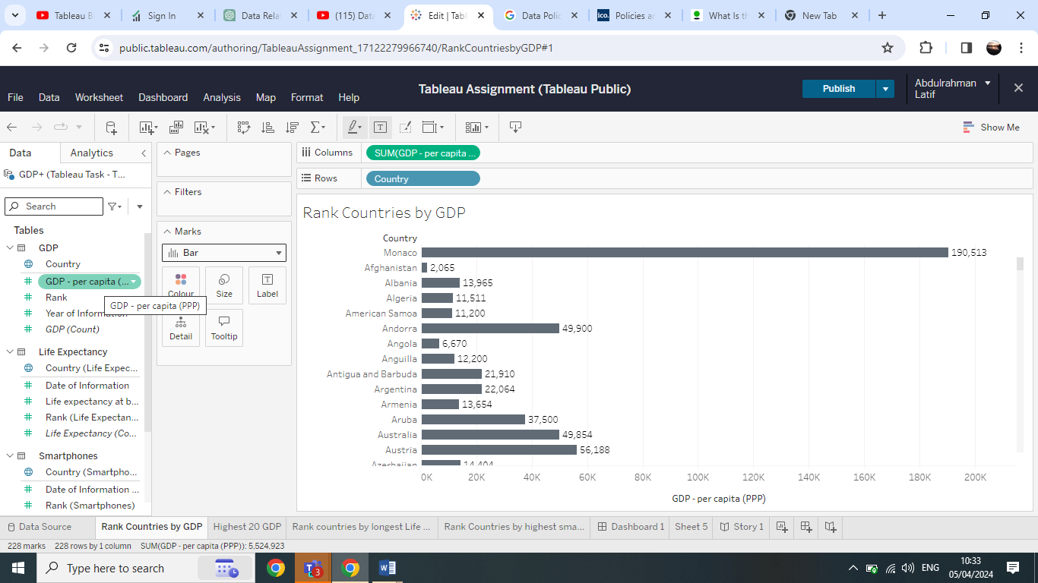

**Change the Chart Colour**

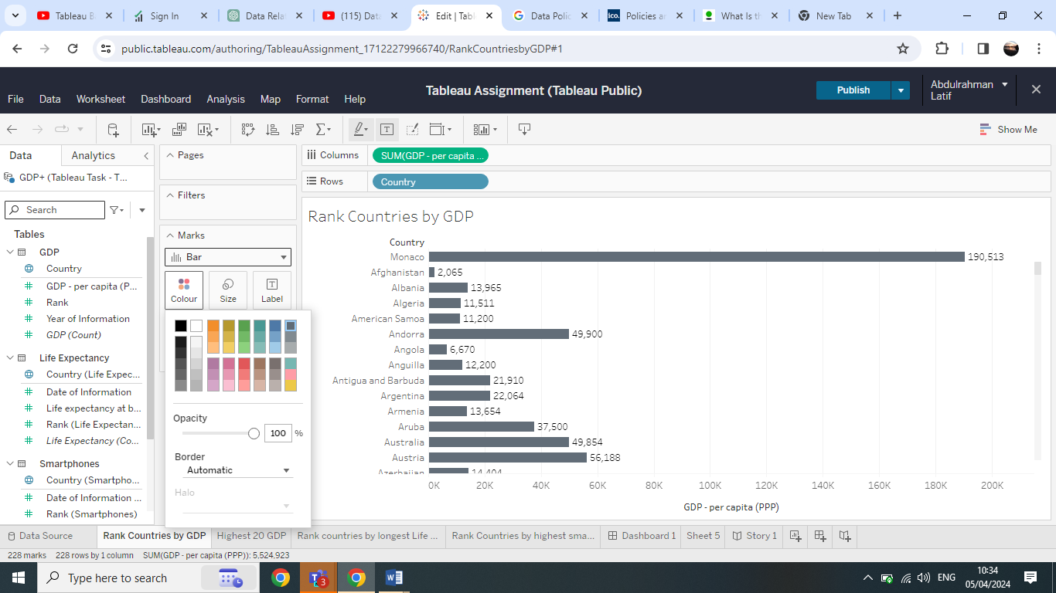

**Showing labels on charts**

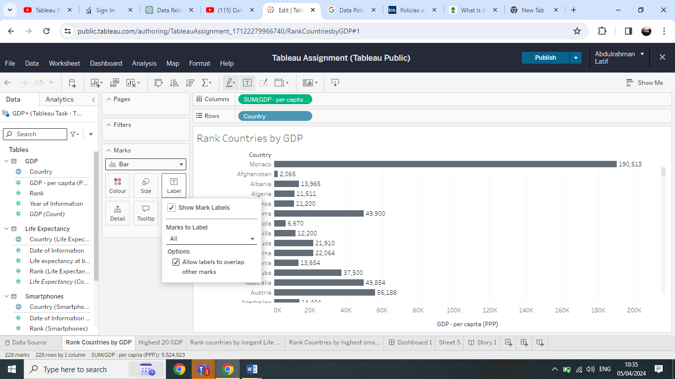

**Editing Filter to Show the highest GDP**

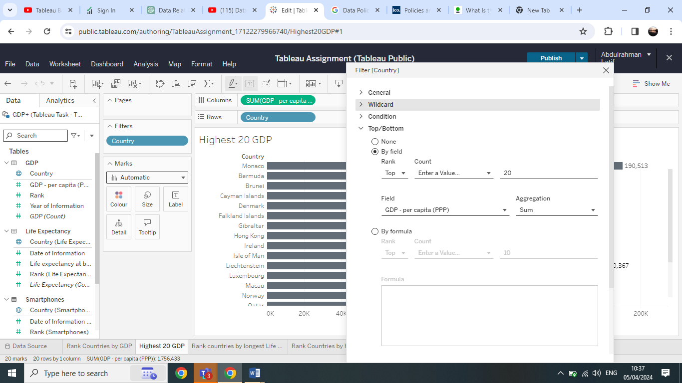

**Finally, creating dashboard using the completed sheets**

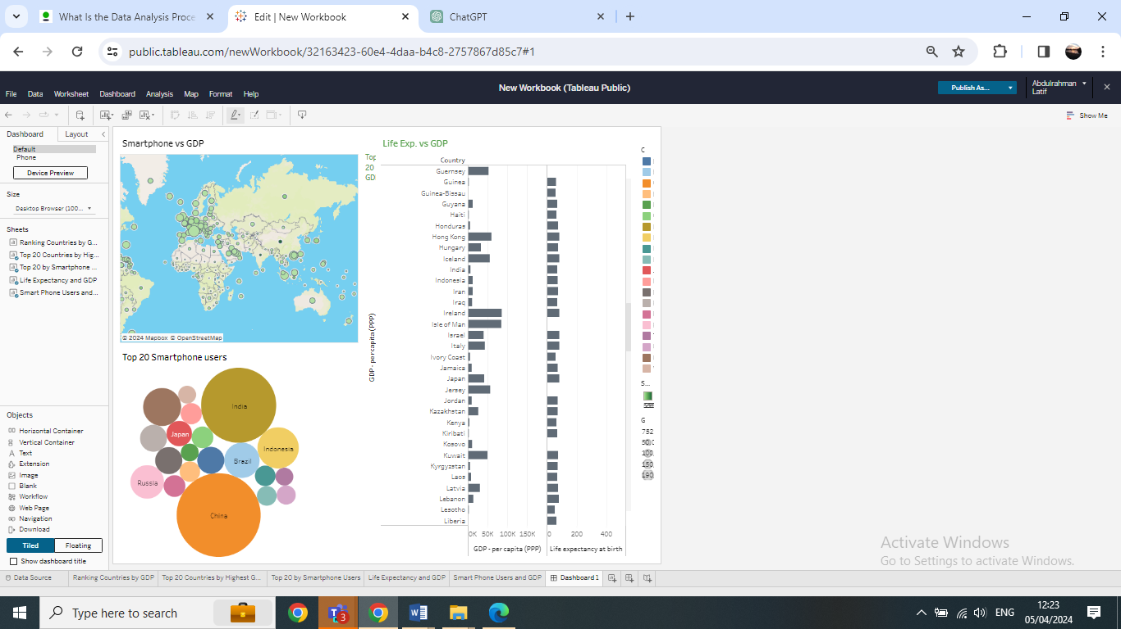

The summary showed that, although in most cases life expectancy related to GDP , there are high life expectancy in countries with low GDP.

Smart phone users in density population countries are the highest regardless of the GDP